**DAILY ONLINE ACTIVITIES SUMMARY**

|  |  |  |  |  |  |  |  |  |
| --- | --- | --- | --- | --- | --- | --- | --- | --- |
| **Date:** | **15/07/2020** | | | | | **Name:** | **Pratibha Shetti** | |
| **Sem & Sec** | **IV sem & B section** | | | | | **USN:** | **4AL18CS062** | |
| **Online Test Summary** | | | | | | | | |
| **Subject** | | **OS** | | | | | | |
| **Max. Marks** | | **30** | | **Score** | | | **-** | |
| **Certification Course Summary** | | | | | | | | |
| **Course** | **Programing fundamental** | | | | | | | |
| **Certificate Provider** | | | **Greatlearning academy** | | **Duration** | | | **3.5hours** |
| **Coding Challenges** | | | | | | | | |
| **Problem Statement1:** -------------------------------------------------------- | | | | | | | | |
| **Status: Executed** | | | | | | | | |
| **Uploaded the report in Github** | | | | | **YES** | | | |
| **If yes Repository name** | | | | | <https://github.com/pratibhashetty-123/Lockdown-coding-java>  <https://github.com/pratibhashetty-123/Lockdown-coding-for-C> | | | |
| **Uploaded the report in slack** | | | | | **YES** | | | |

Online Test Summary: No internals conducted today.

Online Certification Course Summary: In today’s session I register for new couse in coursera that is programming fundamental

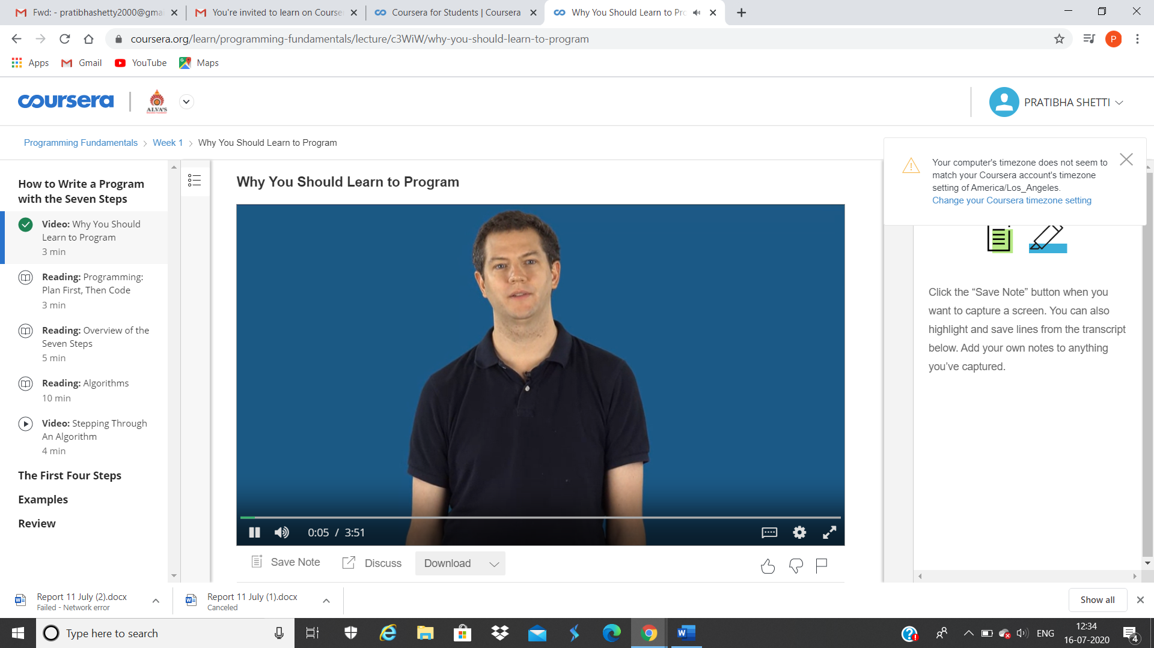

These are the snap shots of today’s session.